**A12 District Calendar**

Hello Lions, I am PDG Ruth Roberts and the Administrator of our newly hosted A12 District Calendar.

Welcome Lions to our new A12 District Calendar. This calendar will be a view only calendar for all A12 Lions to use so everyone will know what is happening in our District. Many times, the officers of A12 want to attend as many functions as they can. Things like Club Charter Anniversaries, Installation nights, Service Projects, Zone and Region meetings etc. Unfortunately, many of these important events are booked on the same dates as other club events. This means our District Officers and other club members are not able to attend some of these events.

To help avoid disappointment to our District Officers, as well as the clubs hosting these important events, we are providing this new A12 District Calendar. Any Officer or Club Member can submit an event with dates, times and other information, and I will add it to the calendar. Hopefully by giving everyone access to view this calendar, we can hope to avoid too many events being booked on the same dates.

I am inviting all A12 Lions to share with me the events that you would like to see District Officers and other Lions Clubs Members to attend your events. I will then add them to the calendars, and they will then be available for all to see. Please take a moment to view the calendar using the steps listed below, and view the month of Aug 2019, and click on the Charter Anniversary event for Penetanguishene to see how you can use this calendar to track those Lions who want to attend your event.

To access this calendar, all you need to do is to click on this link.

<https://teamup.com/ksqzhquv94dgm95q96>

Below are a couple of tips for viewing the calendar.

A) – Since I have 3 available Calendars, (1 – District Events, 2 – Region and Zone, 3 – Club Meetings), you can choose to see 1, 2 or all 3 calendar events in one view.

This view shows the basic calendar screen. The red circle shows the button to click on to expand the area.

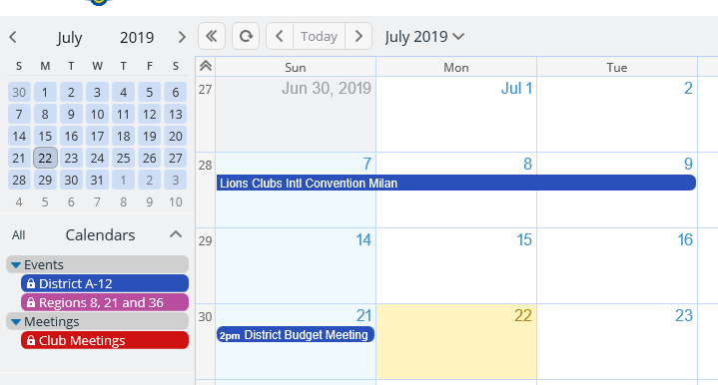1 - This next shot shows the area expanded on the left side of the calendar to see what choices you have for calendars; the red circle is the button to collapse the area.

2 – The green circle shows the 3 available calendars. The 2 Event calendars are now showing, the Club Meeting calendar is not highlighted as I have chosen in this view to hide it.

B) – You can also choose to change the view from monthly to either, Week, Day, Year, etc., just clicking on each of the buttons. These buttons are located at the top right side of the calendar.

The Menu button gives you the choice to print the view that you have chosen.

When changing from one month to the next (by clicking on the down arrow beside the month name) you need to click on a date (any date) of the month you want to change to.